AUTHORS GUIDLINESS*

THE TITLE OF THE PAPER WILL BE WRITTEN WITH CAPITAL LETTERS, CENTERED, AT 7.0 cm FROM THE UPPER EDGE OF A4 FORMAT, ALONG THE ENTIRE WIDTH, TIMES NEW ROMAN, 14 POINTS, BOLD.
⋅ (14 points)
⋅ (14 points)
The first name and the family name will be written with CAPITAL LETTERS, BOLD, CENTERED, 130 mm width, Times New Roman, 12 points, each name being followed by number, and in the footnote the didactic and scientific degree, the position and place of work of the authors (possibly fax, E-mail) are indicated, with italics, 130 mm width, Times New Roman, 11 points.
⋅ (12 points)
⋅ (12 points)
<Tab> Abstract: (Times New Roman, 10 points, bold) The Abstract will only be in English and will have between 50 and 100 words, arranged all over the entire width, single, left – right alignment, all over the width of the printed space, Times New Roman, 10 points.
⋅ (10 points)
⋅ (10 points)
<Tab> Key words: (Times New Roman, 10 points, bold) 5 – 10 words, in English, along the entire width, Times New Roman, 10 points.
⋅ (10 points)
⋅ (10 points)
⋅ (10 points)
<Tab> 1. THE TITLE OF THE CHAPTER IS WRITTEN WITH CAPITAL
LETTERS, BOLD, TIMES NEW ROMAN, 11 POINTS AND WILL BE
NUMBERED WITH ARABIC NUMBERS.
⋅ (11 points)
<Tab> The paper text paragraphs will be left – right aligned. The lines of the entire text will be single spaced with Times New Roman fonts, size 11 points.
The paper will be edited in a language of international circulation (English, French, German) on A4 format (210 x 297), page setup: top 5,6 cm, bottom 4,6 cm, left 3,7 cm, right 3,7 cm, in WORD or WORDPERFET or WINDOWS and the number of pages must be even between 4 and 16. The size of the symbol is given next and is written in the instructions used to assist in editing the text. It indicates a blank line and does not show in the text of the paper, being obtained by pressing <ENTER>. The size of a <Tab> is 1,27 cm. No blank line is left between the paragraphs. Between the last line before the title and the title of the chapter and between the title and the first next line a blank line is left for each.

<Tab> 1.1 Subchapter. Subchapters can be used in the text, numbered with the number of the chapter and a number showing the number of the subtitle within the chapter. The subchapters and the numbers are Times New Roman, 11 points, bold.
⋅ (11 points)
The text is written in new paragraph and not continuing the subtitle, an 11 point blank line being left between the subtitle and the following text.
⋅ (11 points)
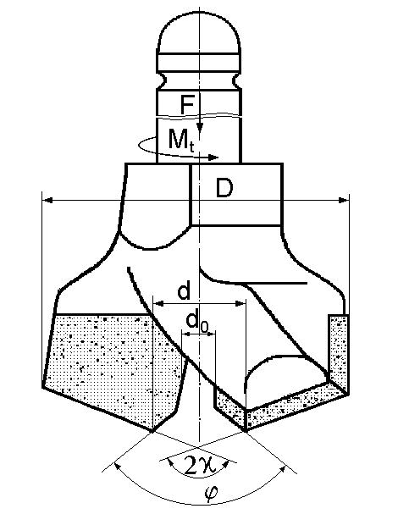
Fig. 1. Detachable bit
2. PRESENTATION OF THE FIGURES
⋅ (11 points)
Figures should be enclosed in the text in the order of their presentation, as far as possible on the page where reference is made to them. They shall be numbered with Arabic numbers. Black – and – white, high contrast figures are recommended. Photos can be used as well, but they should be of good quality, clarity and sufficient contrast. The figures will have a legend (name of the figure), which, along with the number, will be written underneath with Times New Roman, 10 points, centered as to the figure. The figures will be surrounded by text.
⋅ (11 points)
3. PRESENTATION OF THE TABLES
⋅ (11 points)
The tables will be enclosed in the text, a 10 points blank line being left above and under the table, and will be numbered with Arabic numbers. Both the number and the explanations to the table are written with Times New Roman, 10 points, italic, for the number and bold for the explanation to the table, centered in the space of the table and above it. The table entries will be Times New Roman, 10 points, bold, and the data in the table will be Times New Roman, 10 points. The thin lines of the table will be ½ points (0,02 cm), and the thick ones will be ¾ … 1 points (0,03 … 0,04 cm).
⋅ (11 points)
4. PRESENTATION OF THE MATHEMATICAL EQUATIONS
⋅ (11 points)
The mathematical equations will be with times New Roman, 11 points, center of the page and numbered on the right with Arabic numbers between round brackets.
⋅ (8 points)<Blank line 8 point high>
X² + Y² = Z² (1)
⋅ (8 points) < Blank line 8 point high>
An 8 point high blank line is left between the last line before the relation and the relation and between the latter and the next first line.
The last page will be at least 2/3 full.
The pages of the paper will only be numbered by a pencil outside the printing space.
⋅ (11 points)
REFERENCES (will be written according to the model, Times New Roman 10 points).
⋅ (10 points)
- Marian I., Mecanizarea în minerit, Editura Tehnică, Bucureşti, 1969.

* Professor Eng., Ph.D. at the University of Petroşani, adresa email

